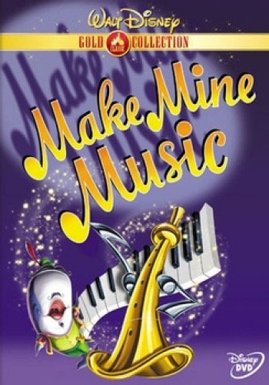

BIGBANDLIBRARY.COM
COLLECTORS’ CHECKLIST: DVDS

Rather than list endless duplications or re-releases of the same thing, especially public domain material or foreign issues, I have tried to pick the most essential editions.
I have not included compact discs which have, as a "bonus," a DVD (such as the BMG "Centennial Collection" series). Those titles are, more appropriately, listed under “Collectors’ Checklist: CDs”.
Most titles listed are “Region1,” in the so-called “NTSC” format, which can be viewed on DVD players typically sold in the U.S. and its territories, Canada, and Bermuda. (DVDs from “Regions 2-6,” which include Europe, Japan, and Australia, are what’s called the “PAL” format and are not compatible with U.S. machines.)

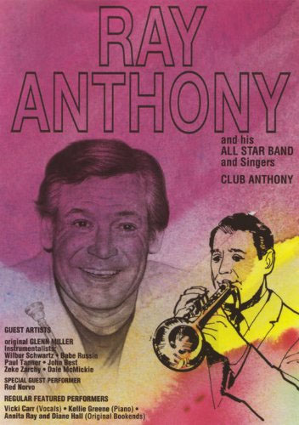

RAY ANTHONY
"Best of the Ray Anthony Show, The" Movies Unlimited [ 2 DVDs ]
"Club Anthony," Aerospace AERO 1004 • with Norvo
"Daddy Long Legs [ 1955 ]," 20th Century Fox Marquee Musicals, 2005 •
"Dream Dancing: Featuring the Mellow Music of Ray Anthony and His Orchestra,"
TMG 17920, Oct 2007 DVD has "extensive interviews and vintage footage";
packaged with 3 CDs of Capitol recordings
“Five Pennies, The [ 1959 ]” – see RED NICHOLS
“Girl Can’t Help It, The [ 1956 ],” 20th Century-Fox Cinema Classics Collection
“Jayne Mansfield Collection,” 20th Century-Fox Cinema Classics Collection, 2006
3 DVDs incl “The Girl Can’t Help It” [ 1956 ]
"Story of the Big Band Era," Aerospace AERO 1001 • with Barnet, J Gray, Brown
“This Could Be the Night [ 1957 ],” Warner Archive Collection, 2012

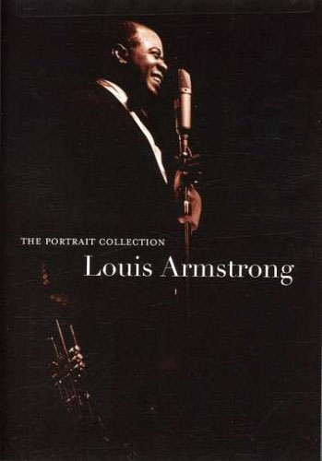

LOUIS ARMSTRONG
“100th Anniversary: Louis Armstrong,” Passport Video, 2001
“100th Anniversary: Louis Armstrong: The person & the performances”
“Atlantic City [ 1944 ]” – see PAUL WHITEMAN
“Encore Series: Louis Armstrong,” St. Clair Vision, 2004
“Five Pennies, The [ 1959 ],” – see RED NICHOLS
“Harlem Roots Vol 2: The Headliners” – see VARIOUS ARTISTS
“Hello, Dolly! [ 1969 ],” 20th Century-Fox (It) PAL format
“High Society [ 1956 ],” Warner Classic Musicals Collection, 2003
“Jazz Legends: Louis Armstrong & His Friends,” Storyville Films, 2004 also incl
Gillespie, Ellington, C Hawkins, Krupa, Hampton, Teagarden, Eldridge
“Jazz Legends: Louis Armstrong and Friends,” Storyville Films, 2007 also incl
Gillespie, Ellington, C Hawkins, Krupa, Hampton, Teagarden, Eldridge
“Legendary Bing Crosby, The,” Infinity Entertainment, 2010
“Legends of Modern Music Vol 2” – see VARIOUS ARTISTS
“Louis Armstrong,” JAZ PAL format
“Louis Armstrong,” Quantum Leap, 2009
“Louis Armstrong: 100th Anniversary, (Rus) PAL format
"Louis Armstrong and Friends 1962," Idem 1141 also incl Hackett
“Louis Armstrong and Friends: C’est Si Bon,” 2004 PAL Region 2
“Louis Armstrong: Good Evening, Ev’rybody,” Image Entertainment, 2010
with Gillespie
“Louis Armstrong: Greatest Performances of the ‘30s, ‘40s, ‘50s, and ‘60s,”
Time-Life Records, 2008 with Krupa
“Louis Armstrong: Live in ’59,” Jazz Icons, 2006 •
“Louis Armstrong: Live in Australia,” Euroarts, 2008
“Louis Armstrong: Live in Stockholm 1962,” Impro-Jazz IJ 521, 2007
“louis armstrong: the louis armstrong show,” ZYX Records, 2005
“Masters of American Music: LA: Louis Armstrong,” Medici Arts, 2009
“Music makers: Man Called Adam, A [ 1966 ],” Lions Gate, 2010
“New Orleans [ 1947 ],” Kino Video, 2000
“on the road with Duke Ellington” – see DUKE ELLINGTON
"Pennies From Heaven" [ 1936 ], Columbia Tristar Home Video, 2003
“Playful Life of Louis Armstrong, The,” Biografilm, 2008
"Portrait Collection, The," Hip-O 1036509, Jan 2008 •
"Satchmo: Louis Armstrong," CMV Legacy CVD 49024 •
“Song Is Born, A [ 1948 ]” - see VARIOUS ARTISTS
“Stars in Concert: The Best of Louis Armstrong: Satchmo At His Best,” Video
Brokers, 2012
“When the Boys meet the Girls [ 1965 ],” Warner Archive, 2011
“Wonderful World of Louis Armstrong, The: An Intimate Portrait of the Father of
Jazz,” Winstar, 2001

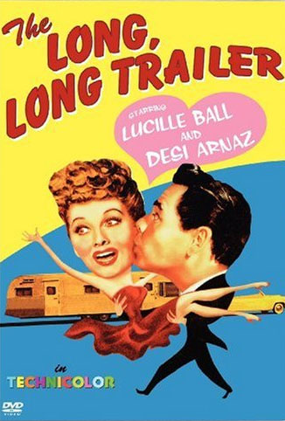

DESI ARNAZ
"CBS Salutes Lucy: The First 25 Years," Image Entertainment, 2001
“Classic All-Star Commercials,” Legend Films, 2013
“Desi Arnaz and His Orchestra” short included with movie “Night and Day” [ 1946 ],
Warner Home Video, 2004
“Escape Artist, The [ 1982 ],” Lionsgate, 2012
“Forever, Darling [ 1955 ],” Warner Home Video
“’I Love Lucy’: 50th Anniversary Special,” Paramount, 2002
“’I Love Lucy’: Season One Vol One,” CBS Video 87898 •
“’I Love Lucy’: Season One Vol Two,” CBS Video 87899 •
“’I Love Lucy’: Season One Vol Three,” CBS Video 87588 •
“’I Love Lucy’: Season One Vol Four,” CBS Video 87589 •
“’I Love Lucy’: Season One Vol Five,” CBS Video 87550 •
“’I Love Lucy’: Season One Vol Six,” CBS Video 87551 •
“’I Love Lucy’: Season One Vol Seven,” CBS Video 87921 •
“’I Love Lucy’: Season One Vol Eight,” CBS Video 87922 •
“’I Love Lucy’: Season One Vol Nine,” CBS Video 87923 •
“'I Love Lucy': The Complete First Season On DVD," Paramount Home Video, 2004
[ 7 discs ]
"'I Love Lucy': The Complete Second Season On DVD," Paramount Home Video, 2004
• [ 5 discs ]
“’I Love Lucy’: The Complete Series,” Paramount, 2007 • [ 34 DVDs ]
"'I Love Lucy': The Complete Third Season On DVD," Paramount Home Video, 2005
[ 5 discs ]
"'I Love Lucy': The Complete Fourth Season On DVD," Paramount Home Video, 2005
[ 5 discs ]
"I Love Lucy': The Complete Fifth Season On DVD," Paramount Home Video, 2005
[ 4 discs ]
"'I Love Lucy': The Complete Sixth Season On DVD," Paramount Home Video, 2006
[ 4 discs ]
“Lucy and Desi: A Home Movie,” MPI Home Video, 2009
"Lucy & Desi Movie Collection, The: 'Too Many Girls' [ 1940 ] / 'The Long, Long Trailer'
[ 1954 ] / 'Forever, Darling' [ 1955 ]," Warner Home Video 76090 • [ 3 DVDs ]
"Lucy Mania: Lucy and Desi Visit Ed Sullivan [ 1956 ]," Goodtimes
“Lucy Mania: Lucy – Desi Westinghouse Special, The,” Goodtimes, 2001
“Lucy’s Really Lost Moments: First Time in Color!,” Legend Films, 2008
“Long, Long Trailer, The [ 1954 ],” Warner Home Video
“Papa Se Casa [ = Father Takes a Wife ],” RKO Filmoteca PAL Region 2
“Too Many Girls [ 1940 ],” RKO Pictures

GEORGIE AULD
"New York, New York [ 1977 ]," MGM 1007430, 2005 •

CHARLIE BARNET
“Fabulous Dorseys, The [ 1947 ],” – see THE DORSEY BROTHERS
“Song Is Born, A [ 1948 ]” – see VARIOUS ARTISTS
“Startime: The Swingin’ Singin’ Years [ 1960 ]” – see VARIOUS ARTISTS
"Story of the Big Band Era" – see RAY ANTHONY

COUNT BASIE
"Count Basie At Carnegie Hall [ Mar 20, 1981 ]," Kultur D2810 •
“Count Basie: Live in ’62,” Jazz Icons DVWW-JICOB, 2006 •
"Count Basie: Swinging At His Best," Passport 1603, 2005
"Harlem Renaissance: Music & Rhythms That Started . . . “ – see VARIOUS ARTISTS
"Cinderfella, Jerry Lewis As [ 1960 ]," Paramount Home Video
"Last of the Blue Devils, The [ 1973 ]," Kino Video K168, 2001 • also with McShann
"Norman Granz' Jazz in Montreux Presents: Count Basie Big Band '77," Eagle Eye
Media EE 39062-9, 2006 •
"Norman Granz' Jazz in Montreux Presents: Count Basie Jam '75," Eagle Eye Media
EE 39055-9, 2004 •
"Norman Granz' Jazz in Montreux Presents: Ella & Basie '79," Eagle Eye Media EE
39057-9, 2004 •
"Oscar Peterson & Count Basie: Together in Concert 1974," Impro-Jazz IJ 538, 2008
"Ralph Gleason's Jazz Casual: Instrumentals Vol 1” – see VARIOUS ARTISTS
"Then As Now, Count's the King: A Film By Gary Keys," MVD Visual MVD50720,
Mar 2011 •

THE COUNT BASIE ORCHESTRA
“Big Bands At Disneyland [ 1984 ]” DVD-R TRANSFER •
"Diane Schuur & The Count Basie Orchestra," Image Entertainment, 2004

LOUIS BELLSON
“Cobham Meets Bellson,” VIEW Video, 2007
"Louis Bellson and His Big Band [ 1983 ]," VIEW Video, 2003
“Pete York’s Super Drumming Vol 1,” Inakustic, 2002
“Pete York’s Super Drumming Vol 3,” Inakustic, 2008
see also DUKE ELLINGTON

TEX BENEKE
“Glenn Miller: A Moonlight Serenade [ 1984 ],” Magnum Entertainment DVD-R
TRANSFER •
“Tex Beneke And His Orchestra: with ‘Music in the Miller Mood,’ [ 1996 ]” Florida Public
Broadcasting (FPB) DVD-R TRANSFER •
“Together In Concert: Tex Beneke and His Orchestra / Bob Eberly / Helen O’Connell,”
PBS DVD-R TRANSFER •
see also GLENN MILLER

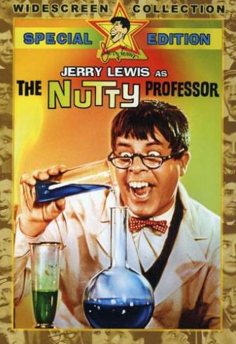

LES BROWN
“Big Bands At Disneyland [ 1984 ]” DVD-R TRANSFER •
“Bob Hope Christmas Special, The [ 1967 ],” PR Studios, 2010 [ 2 DVDs ]
“Bob Hope: The Vietnam Years: 1965,” 2006
“Bob Hope: The Vietnam Years: 1966,” 2006
“Bob Hope: The Vietnam Years: 1968,” 2006
“Bob Hope: The Vietnam Years: 1971,” 2006
“Bob Hope’s Salute to the Troops,” 2006
"Nutty Professor, The, Jerry Lewis As [ 1963 ]," Warner Home Video, 2000
“Sentimental Journey, A [ 1985 ]” DVD-R TRANSFER • with Patty Andrews
"Story of the Big Band Era" – see RAY ANTHONY

LES BROWN’S BAND OF RENOWN DIRECTED BY LES BROWN JR.
“Music of Your Life . . . : Starring: Neal McCoy . . .,” DPTV Media DPT-DV-315,
2011 •
HENRY BUSSE
“Fabulous Dorseys, The [ 1947 ]” – see THE DORSEY BROTHERS
"Henry Busse and His Orchestra" film short included as "special feature" with
Edward G. Robinson film "Brother Orchid" [ 1940 ] available separately or as part of
set "Warner Brothers Pictures Gangsters Collection Vol 3", Warner Home Video,
Mar 2008

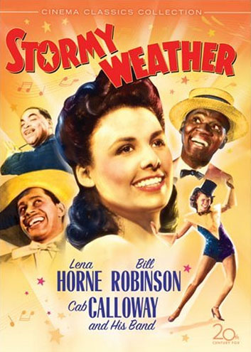

CAB CALLOWAY
“All American Presents C Calloway: Hi-De-Ho [ 1947 ],” Storyville Films 16053, 2004 •
“Betty Boop: The Essential Collection Vol 1,” Olive Films, 2013
“Big Bands At Disneyland [ 1984 ]” DVD-R TRANSFER •
"Blues Brothers, The [ 1980 ]: Collector's Edition," Universal, 2003
"Cab Calloway: Swinging At His Best," Passport 1605, 2005
"Harlem Renaissance: Music & Rhythms That Started . . . “ – see VARIOUS ARTISTS
"Hi-De-Ho" film short included as "special feature" with Humphrey Bogart film
"Black Legion" [ 1937 ] available separately or as part of set "Warner Brothers
Pictures Gangsters Collection Vol 3", Warner Home Video, Mar 2008
“janet jackson: Design of a Decade 1986/1996,” A&M, 2001
“janet jackson: The Rhythm Nation Compilation,” A&M, 2001
“Jumpin’ and Jivin’: Vol 1” – see VARIOUS ARTISTS
“Legends of Modern Music Vol 2” – see VARIOUS ARTISTS
"Littlest Angel, The [ 1969 ],” Westlake Entertainment Group, 2004
"Singing Kid, The [ 1936 ]," Warner Archive Collection, Jul 2009 •
"Manhattan Merry-Go-Round [ 1937 ]," Alpha Video ALP 5984D, Jan 2010 •
also with Prima, Lewis
“Stormy Weather [ 1943 ],” 20th Century-Fox Cinema Classics Collection, 2005 •
also with Waller
“Swing Era: Cab Calloway: Hi-De-Ho [ 1947 ] and Other Movies,” Idem 1119, 2003
“W.C. Fields Comedy Favorites Collection,” Universal, 2013 incl film “International
House” [ 1933 ] with Calloway

BENNY CARTER
“Benny Carter All-Stars,” Gazell Records, 2011
“Benny Carter: Live At the Smithsonian”
"Norman Granz Jazz in Montreux Presents: Benny Carter '77," Eagle Eye Media, 2004
"Jazz Masters Series: Benny Carter," Shanachie 6319, 2005
"Symphony in Riffs," Rhapsody Films, Oct 2007

CARMEN CAVALLARO
“Hollywood Canteen [ 1944 ]” - see JIMMY DORSEY

BOB CROSBY
“Five Pennies, The [ 1959 ]” – see RED NICHOLS
“Golden Anniversary Tribute [ 1985 ],” Crosby Music Agency DVD-R TRANSFER •
“Jack Benny Show Vol 4, The,” Alpha Video, 2004
"Presenting Lily Mars [ 1943 ]," Warner Home Video 79526, 2006 • also with
T Dorsey

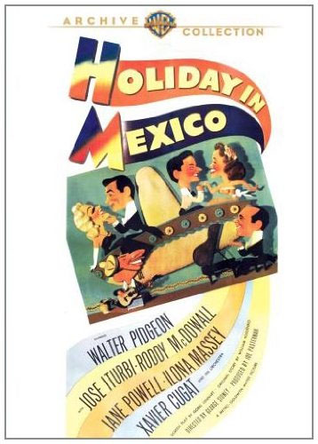

XAVIER CUGAT
"Bathing Beauty [ 1944 ]," included as part of the set "TCM Spotlight: Esther Williams,
Volume1," Warner Home Video, Jul 2007 also with James
“Date with Judy, A [ 1948 ],” Warner Archive Collection, 2011 •
“En Una Isla Contigo [ = On An Island with You ] [ 1948 ]” NOTE: PAL Region 2
“Heat’s On, The [ 1943 ],” Sony Pictures Choice Collection
"Holiday in Mexico [ 1946 ]," Warner Archive Collection, Feb 2010 •
"Luxury Liner [ 1948 ]," Warner Archive Collection, Jun 2009 •
"This Time for Keeps [ 1947 ]," included as part of the set "TCM Spotlight: Esther
Williams, Volume 2," Warner Home Video, Oct 2009
"Thrill of a Romance [ 1945 ]," included as part of the set "TCM Spotlight: Esther
Williams, Volume 2," Warner Home Video, Oct 2009 also with T Dorsey
"Two Girls and a Sailor [ 1944 ]," Warner Archive Collection, Jun 2009 •
also with James
"You Were Never Lovelier [ 1942 ]," Columbia Tristar Home Video 03703, 2004 •

THE NEW XAVIER CUGAT ORCHESTRA DIRECTED BY ADA CAVALLO
“U-Got Cugat!: Live In Palm Beach,” ACK Enterprises, Inc., 2006 •

THE DORSEY BROTHERS
“Fabulous Dorseys, The [ 1947 ],” Critics’ Choice Video CCD 1010, 2003 • also with
Barnet, Whiteman, Busse NOTE: disc also contains 1955 episode of TV program
“Stage Show”
see also JIMMY DORSEY
see also TOMMY DORSEY

JIMMY DORSEY
“Fabulous Dorseys, The [ 1947 ]” – see THE DORSEY BROTHERS
"Four Jills in a Jeep [ 1944 ]," 20th Century Fox, Aug 2008 • available separately or
as part of set "The Alice Faye Collection Volume 2," 20th Century Fox, Aug 2008
“Hollywood Canteen [ 1944 ],” Warner Brothers, 2008 • also with Cavallaro
"I Dood It [ 1943 ]," Warner Archive Collection, Feb 2010 •
"Jimmy Dorsey and His Orchestra" [ 1938 Vitaphone short ] included as a bonus with
"Jezebel," Warner Home Video, 2006
"Lost in a Harem [ 1944 ]," Warner Home Video 79458, 2006 • disc also includes
movie “Abbott and Costello in Hollywood”

THE JIMMY DORSEY ORCHESTRA DIRECTED BY LEE CASTLE
“Big Bands At Disneyland [ 1984 ]” DVD-R TRANSFER •

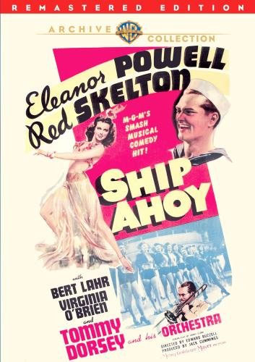

TOMMY DORSEY
"Broadway Rhythm [ 1944 ]," Warner Archive Collection, Jun 2009 •
"Du Barry Was a Lady [ 1943 ]," Warner Home Video 79631, Jun 2007 •
“Fabulous Dorseys, The [ 1947 ]” – see THE DORSEY BROTHERS
"Girl Crazy [ 1943 ]" included in "Mickey Rooney & Judy Garland Collection," Warner
Home Video, Sep 2007
"Presenting Lily Mars [ 1943 ]" - see BOB CROSBY
“Ship Ahoy [ 1942 ],” Warner Archive Collection, 2011 •
“Song Is Born, A [ 1948 ]” – see VARIOUS ARTISTS
“Thrill of a Romance [ 1945 ]” – see XAVIER CUGAT

THE TOMMY DORSEY ORCHESTRA DIRECTED BY BUDDY MORROW
“Big Bands At Disneyland [ 1984 ]” DVD-R TRANSFER •

EDDY DUCHIN
"Eddy Duchin Story, The [ 1956 ]" - see TRIBUTES

BILLY ECKSTINE
"Billy Eckstine Sings... Dizzy Gillespie Swings," Koch Entertainment, 2004
"Jojo Dancer, Your Life Is Calling [ 1986 ]," Columbia Tristar, 2004
"Let's Do It Again (1975)," Warner Home Video, 2004
"Skirts Ahoy! [ 1952 ]," Warner Bros. Archive Collection, 2011 •

ROY ELDRIDGE
“Jazz Legends: Louis Armstrong & His Friends” - see LOUIS ARMSTRONG

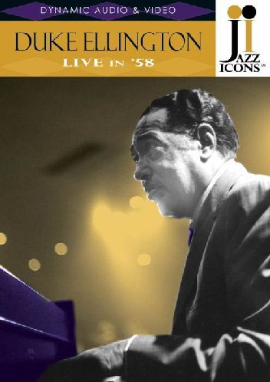

DUKE ELLINGTON
"Belle of the Nineties [ 1934 ]," Image Entertainment, 2000
"Berlin Concert 1964," Impro-Jazz IJ 510, 2006
"Berlin Concert 1969," Impro-Jazz IJ 509, 2006
"Check and Double Check [ 1930 ]," WEA Corp, 2002
"Duke Ellington: In Hollywood," Idem 1129
"Duke Ellington-Live At the Tivoli Gardens," Image Entertainment, 2003
"Duke Ellington: Live in '58," Jazz Icons, Sep 2007
"Duke Ellington: Rare Video Footage," Legacy Entertainment LEG5004D, 2005
"Duke Ellington: Swinging At His Best," Passport 1602, 2005
"Duke Ellington: The Classics Hollywood Years," Efor Films, 2004
"Duke Ellington's Sacred Concerts," Image Entertainment, 2000
"Harlem Renaissance: Music & Rhythms That Started . . . “ – see VARIOUS ARTISTS
"Intimate Duke Ellington, The" Image Entertainment, 2003
"Lou Rawls Show, The: with Duke Ellington," View 2319D, 2005
"Memories of Duke," Music Video Distributors DJ-855, 2002 •
“Norman Granz Presents: Duke: the Last Jam Session,” Eagle Vision, 2008
"on the road with Duke Ellington," Docu Rama NVG-9502, 2002 • with Armstrong
“Reminiscing in Tempo: By Gary Keys,” MVD Visual MVD50710, 2011 •
"Swing Era: Duke Ellington [and] Lionel Hampton" – see VARIOUS ARTISTS
see also THE DUKE ELLINGTON ORCHESTRA DIRECTED BY MERCER
ELLINGTON

THE DUKE ELLINGTON ORCHESTRA DIRECTED BY MERCER ELLINGTON
"Duke Ellington's Sophisticated Ladies," Kultur, 2005
"Michael Feinstein & Friends in Concert," Kultur, 2005
see also DUKE ELLINGTON

SKINNAY ENNIS
“College Swing [ 1938 ]” - see SHEP FIELDS
“Radio Stars On Parade [ 1945 ]” – see FREDDY MARTIN

MAYNARD FERGUSON
"Live from Seattle: Diane Schuur with Maynard Ferguson and his Big Bop Nouveau
Band Live from the King Cat Theatre," 2007
"Live from Seattle: Maynard Ferguson Live from the King Cat Theatre"
"Maynard Ferguson Big Band / Tony Scott Quartet: Live in Prague," Impro-Jazz IJ 539,
2008
"Maynard Ferguson: Live - At the Top"
"Maynard Ferguson: Tribute," 2007

SHEP FIELDS
"Big Broadcast of 1938, The: Bob Hope: The Tribute Collection," Universal 21462,
2002 • NOTE: disc also contains movie “College Swing [ 1938 ]” with Ennis

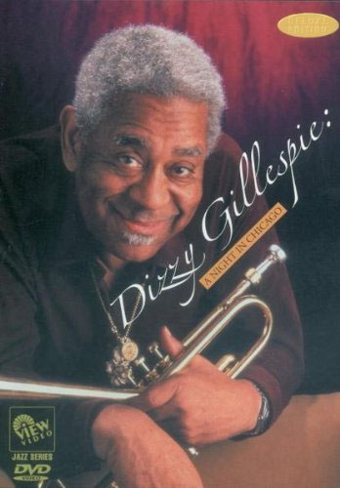

DIZZY GILLESPIE
"Billy Eckstine Sings... Dizzy Gillespie Swings" – see BILLY ECKSTINE
"Dizzy Gillespie: A Night in Chicago," View 2334 •
"Dizzy Gillespie Live At the Royal Festival Hall, London," Pioneer Video, 2001
"Dizzy Gillespie: Live in Montreal," Image Entertainment, 2002
"Dizzy's Dream Band," Fox Lorbor, 2001
"Great Day in Harlem, A: The Story and Sounds . . .” – see VARIOUS ARTISTS
"Harlem Double Feature: Jivin' in Be Bop / Beware" – see LOUIS JORDAN
“Jazz Legends: Louis Armstrong & His Friends” – see LOUIS ARMSTRONG
"Norman Granz’ Jazz in Montreux: D Gillespie Sextet '77," Eagle Eye Media, 2005 •
"Ralph Gleason's Jazz Casual: Instrumentals Vol 1” – see VARIOUS ARTISTS

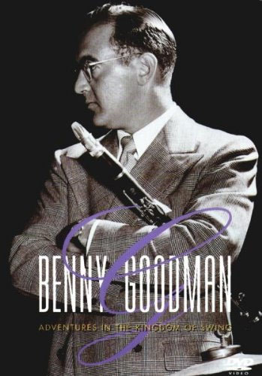

BENNY GOODMAN
“Aurex Jazz Festival: King of Swing: Benny Goodman Special Live [ 1980 ],”
DVD-R TRANSFER •
"Benny Goodman: Adventures in the Kingdom of Swing," CMV Legacy
CVD 49186, 2000 •
“Benny Goodman: Let’s Dance [ 1985 ]” DVD-R TRANSFER • with Wilson
"Benny Goodman Story, The [ 1955 ]," Universal 22636, 2003 •
"Gang's All Here, The [ 1943 ]," 20th Century Fox, Feb 2007 • also available as
part of set "The Carmen Miranda Collection," 20th Century Fox, Jun 2008
"Hollywood Hotel [ 1937 ]," Warner Home Video, Sep 2008 • also available as part
of set "The Busby Berkeley Collection Volume 2," Warner Home Video, Sep 2008
“Live!: Benny Let’s Dance [ 1985 ],” DVD-R TRANSFER •
"Sid Caesar Collection: The Magic of Live TV" – see VARIOUS ARTISTS
“Song Is Born, A [ 1948 ]” – see VARIOUS ARTISTS
“Sweet and Low-Down [ 1944 ],” 20th Century Fox Cinema Archives, 2013 •

GLEN GRAY
“Time Out for Rhythm [ 1941 ],” Sony Pictures Choice Collection 40865, 2012
also with Vallee •

JERRY GRAY
"Story of the Big Band Era"- see RAY ANTHONY

JOHNNY GREEN
"Johnny Green and His Orchestra" 1935 film short included as "special feature" with
1935 Errol Flynn film "Captain Blood" (available separately or as part of the set
"Errol Flynn: The Signature Collection"), Warner Home Video, Apr 2005

BOBBY HACKETT
"Louis Armstrong and Friends 1962" - see LOUIS ARMSTRONG

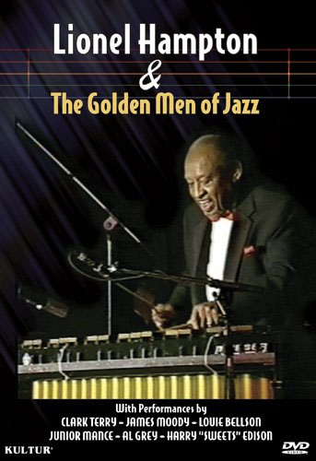

LIONEL HAMPTON
“Big Bands At Disneyland [ 1984 ]” DVD-R TRANSFER •
“Lionel Hamtpon and the Golden Men of Jazz,” Geneon Entertainment, 2005
"Lionel Hampton & The Golden Men of Jazz," Kultur D4697, 2010 •
"Lionel Hampton: Jazz Legend: King of the Vibes," Hudson Music HD-DVD-LH21,
2005 •
"Lionel Hampton: Swinging At His Best," Passport DVD 1604, 2005 •
“Lionel Hampton: Live in ’58,” Jazz Icons 2.119012, 2008 •
“Jazz Legends: Louis Armstrong & His Friends” – see LOUIS ARMSTRONG
“Song Is Born, A [ 1948 ]” – see VARIOUS ARTISTS
"Swing Era: Duke Ellington [and] Lionel Hampton" – see VARIOUS ARTISTS

PHIL HARRIS
"Jungle Book, The [ 1967 ]” – see LOUIS PRIMA

COLEMAN HAWKINS
"Coleman Hawkins - Sweets Edison Quintet: London Concert 1964," Impro-Jazz IJ 508,
2006
“Jazz Legends: Louis Armstrong & His Friends” - see also LOUIS ARMSTRONG
"Live in '62 and '64," Jazz Icons, Oct. 2009

HORACE HEIDT
"Pot o'Gold [ 1941 ]," Image Entertainment ID5387DSDVD, 2000 •

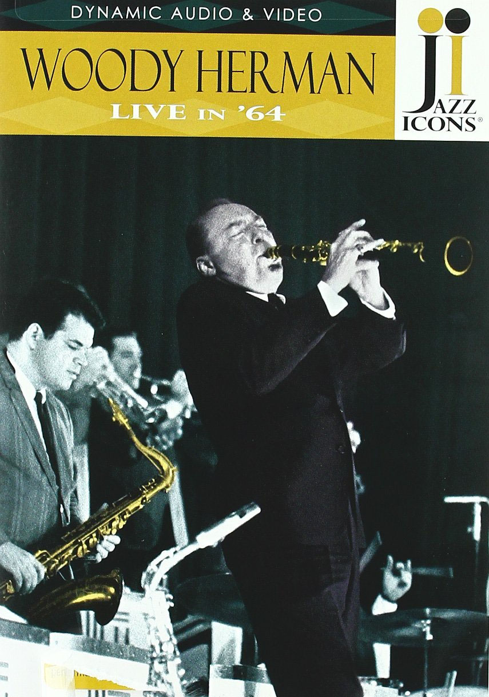

WOODY HERMAN
"20th Century Jazz Masters: Woody Herman and His Swingin' Herd," Idem 1145
“Big Bands At Disneyland [ 1984 ]” DVD-R TRANSFER •
"Ralph Gleason's Jazz Casual: Thad Jones & Mel Lewis and Woody Herman," 2003
“Startime: The Swingin’ Singin’ Years [ 1960 ]” – see VARIOUS ARTISTS
"Woody Herman: Blue Flame: Portrait of a Jazz Legend," Jazzed Media,
Nov 2012 •
"Woody Herman: Live in '64," Jazz Icons 2.119016, Oct 2009 •
"Woody Herman: Woodchopper's Ball," Image Entertainment IDO900GZDVD,
2001 •

EDDY HOWARD
“Startime: The Swingin’ Singin’ Years [ 1960 ]” – see VARIOUS ARTISTS

ILLINOIS JACQUET
“Texas Tenor: The Illinois Jacquet Story,” EforFilms 2869015 •

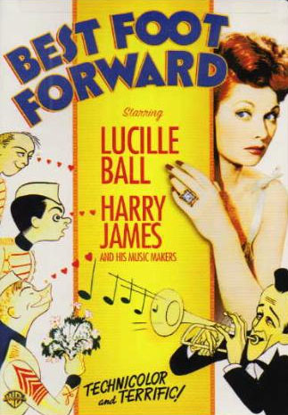

HARRY JAMES
“Bathing Beauty [ 1944 ]” – see XAVIER CUGAT
"Best Foot Forward [ 1943 ]," Warner Home Video 79744, 2006 •
“Big Bands, The: Harry James [ WGN-TV, 1965 ],” DVD-R TRANSFER •
“Carnegie Hall [ 1947 ]” – see VAUGHN MONROE
“Films of Harry James, The” DVD-R TRANSFER •
"If I'm Lucky [ 1946 ]," 20th Century Fox, Jun 2008 • also available as part of set
"The Carmen Miranda Collection"
"ladies man, Jerry Lewis as the [ 1961 ]," Paramount Home Video 06015, 2004 •
"Private Buckaroo [ 1942 ]," Madacy Entertainment DVD9 9258, 2001 •
“Springtime in the Rockies [ 1942 ],” 20th Century Fox Cinema Archives, May 2014
“Two Girls and a Sailor [ 1944 ]” – see XAVIER CUGAT

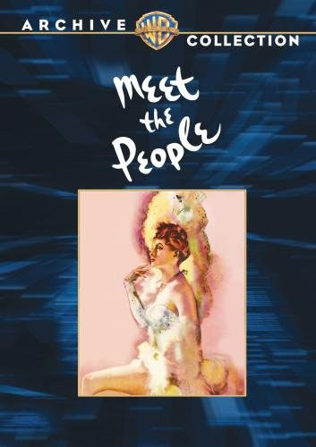

SPIKE JONES
"Jazz Documentary, A: The Spike Jones Story," Navarre Entertainment, 2004
“Meet the People [ 1944 ],” Warner Bros Archive Coll, Jul 2009 • also with Monroe
“Spike Jones: The Funniest Show on Earth,” SJ2 Entertainment / Infinity
IEG2176, 2009 • [ 3 DVDs ]
"Spike Jones: The Legend," SJ2 Entertainment / Infinity SPK2012, Oct. 2007 •
[ 3 DVDs with bonus music CD; includes two "Colgate Comedy Hour" programs
from 1951, two "All Star Revue" shows from 1952, a 1961 "Ed Sullivan Show"
appearance, etc. ]

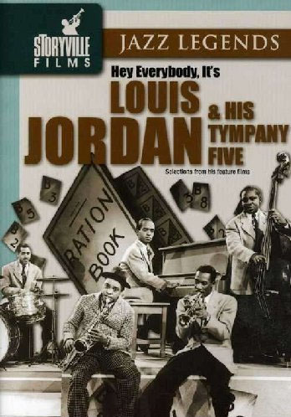

LOUIS JORDAN
"Harlem Double Feature: Jivin' in Be Bop / Beware," Alpha Video ALP5494D
[ Jordan in "Beware," Gillespie in "Jivin' in Be Bop" ]
"Harlem Double Feature: Look-Out Sister! / Big Timers," Alpha Video ALP5025D,
2006 • [ Jordan in "Look-Out Sister!" ]
"Harlem Double Feature: Juke Joint / Reet, Petite, and Gone," Alpha Video ALP5091D,
2006 • [ Jordan in "Reet, Petite, and Gone" ]
“Harlem Roots Vol 2: The Headliners” – see VARIOUS ARTISTS
“Jazz Legends: Hey Everybody, It’s Louis Jordan & His Tympany Five,” Storyville
Films
“Jumpin’ and Jivin’: Vol 1” – see VARIOUS ARTISTS
“Legends of Modern Music Vol 2” – see VARIOUS ARTISTS
"Platinum Performances: Louis Jordan and the Tympany Five," BMG Special Products
“Startime: The Swingin’ Singin’ Years [ 1960 ]” – see VARIOUS ARTISTS
72333-80008-9, 2000 •
"Swing Era: Louis Jordan: Films and Soundies," Idem 1124
“Swing Parade of 1946” – see WILL OSBORNE

SAMMY KAYE
“Iceland [ 1942 ],” 20th Century Fox Cinema Archives, Dec 2013

HAL KEMP
see Skinnay Ennis

STAN KENTON
"Jazz Scene USA: Frank Rosolino / Stan Kenton," Shanachie, 2001
"Stan Kenton: Artistry in Rhythm," Aerospace AERO 1002
“Stan Kenton: Artistry in Rhythm: Portrait of a Jazz Legend,” Jazzed Media
JM9004, 2011 •

ANDY KIRK
"Killer Diller," Alpha Video ALP5227D, 2006 •

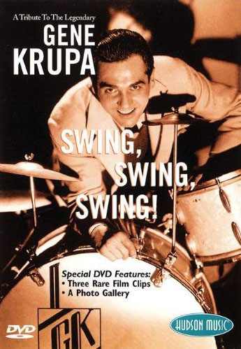

GENE KRUPA
"Ball of Fire [ 1941 ] ," MGM Movie Legends, May 2007 •
"Beat the Band [ 1947 ]," Warner Archive Collection, May 2012 •
"Gene Krupa: Jazz Legend 1909-1973," Warner Brothers Publishing, 2004
“Gene Krupa: Raw Footage by Request (1971 & 1973),” DVD-R TRANSFER •
"Gene Krupa Story, The [ 1959 ]," Columbia Tristar Home Video 03760, 2004 •
"George White's Scandals [ 1945 ]," Warner Archive Collection, Oct 2009 •
“Louis Armstrong: Greatest Performances of the ‘30s, ‘40s, ‘50s, and ‘60s” – see
LOUIS ARMSTRONG
"Tribute to the Legendary Gene Krupa, A: Swing, Swing, Swing!," Hudson Music
HD-DVD-GK21, 2002 •

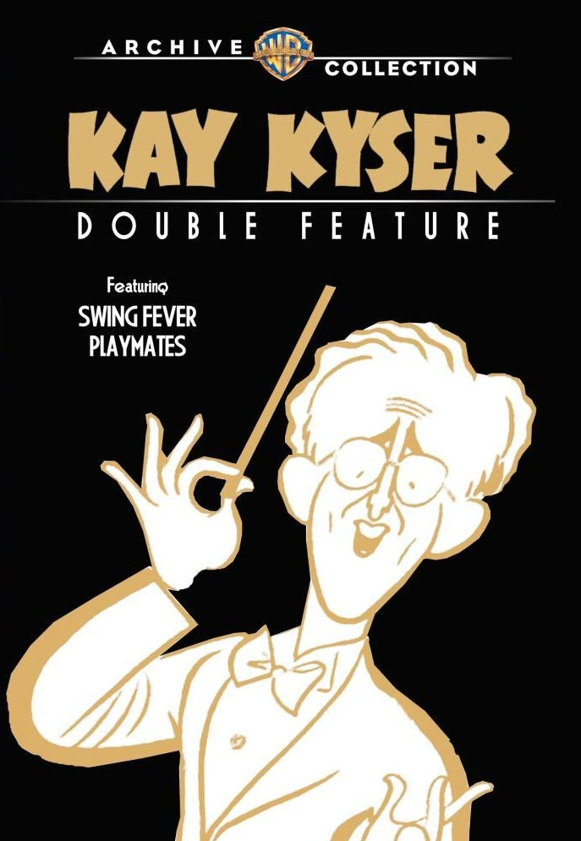

KAY KYSER
“2 Song DVD: Kay Kyser: KayKyserBook.Com,” DVD-R TRANSFER •
"Carolina Blues [ 1944 ]," Columbia Pictures 39553, 2012 •
“Kay Kyser Collection, The,” DVD-R TRANSFER • incl “That’s Right – You’re
Wrong [ 1939 ]”; “You’ll Find Out [ 1940 ]”; “Playmates [ 1941]”; “My Favorite Spy
[ 1942 ]”; “Swing Fever [ 1943 ]”; “Around the World [ 1943 ]”; “Carolina Blues
[ 1944 ]”
"Kay Kyser Double Feature: Swing Fever [ 1943 ] / Playmates [ 1941 ]," Warner Bros
Archive Collection, 2012 •

TED LEWIS
"Manhattan Merry-Go-Round [ 1937 ]" - see CAB CALLOWAY

GUY LOMBARDO
“Film Classics: Big Bands: G Lombardo and His R Canadians” DVD-R TRANSFER •

JIMMIE LUNCEFORD
"Blues in the Night [ 1941 ]," Warner Home Video, Jul 2008 also with Osborne
"Melody Master: Jimmie Lunceford and His Orchestra" [ short ], Warner Home Video,
Aug. 2005 [ included as a "special feature" with "Follow the Fleet" individual DVD or "Astaire & Rogers Collection, Volume 1 ]

FREDDY MARTIN
“Mayor of 44th St., The [ 1942 ],” Warner Bros. Archive Collection, 2014 also incl.
“Radio Stars On Parade [1945 ]” with Skinnay Ennis •
"Melody Time [ 1948 ],” Walt Disney Home Video, 2000
“Startime: The Swingin’ Singin’ Years [ 1960 ]” – see VARIOUS ARTISTS

RAY McKINLEY
“Big Bands At Disneyland [ 1984 ]” DVD-R TRANSFER •

JAY McSHANN
"Last of the Blue Devils, The [ 1973 ]" - see COUNT BASIE

GLENN MILLER
"Dead Men's Secrets: Whatever Happened to Glenn Miller?," The History Channel
AAE-72445, 2002 •
"Orchestra Wives [ 1942 ]," 20th Century Fox Studio Classics 35, 2005 •
“Sun Valley Serenade [ 1941 ],” DVD-R TRANSFER •
see also TEX BENEKE
see also THE GLENN MILLER ORCHESTRA DIRECTED BY DICK GERHART
see also THE GLENN MILLER ORCHESTRA DIRECTED BY LARRY O’BRIEN
see also TRIBUTES

THE GLENN MILLER ORCHESTRA DIRECTED BY DICK GERHART
“Big Bands At Disneyland [ 1984 ]” DVD-R TRANSFER •
“Live in Concert [ 1988 ],” DVD-R TRANSFER •
see also GLENN MILLER

THE GLENN MILLER ORCHESTRA DIRECTED BY LARRY O’BRIEN
"The Glenn Miller Spectacular: All the Greatest Hits!," MPI, 2004 •
see also GLENN MILLER

LUCKY MILLINDER
"Boarding House Blues," Alpha Video ALP4652D, 2005 •
"Harlem Double Feature: Paradise in Harlem / Burlesque in Harlem," Alpha Video
ALP5276D, Feb 2007 • [ Millinder in "Paradise in Harlem" ]

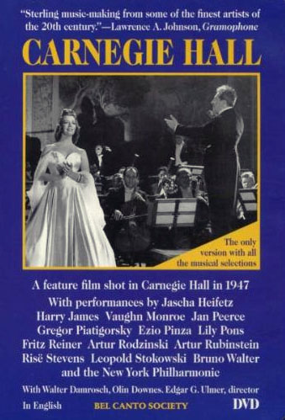

VAUGHN MONROE
"Carnegie Hall [ 1947 ]," Bel Canto Society #D791 / Kino Video, 2001 also with James
"Meet the People [ 1944 ]" – see SPIKE JONES
“Startime: The Swingin’ Singin’ Years [ 1960 ]” – see VARIOUS ARTISTS
“Vaughn Monroe Show, The,” DVD-R TRANSFER •

OZZIE NELSON
"Adventures of Ozzie and Harriet, The: Volume 1," Alpha Video
"Adventures of Ozzie and Harriet, The: Volume 2," Alpha Video
"Adventures of Ozzie and Harriet, The: Volume 3," Alpha Video
"Adventures of Ozzie and Harriet, The: Volume 4," Alpha Video
"Adventures of Ozzie and Harriet, The: Volume 5," Alpha Video, 2007
"Adventures of Ozzie and Harriet, The: Volume 6," Alpha Video, Sep 2008
“Nelson Family Presents The Adventures of Ozzie & Harriet: Christmas With The
Nelsons, The,” Shout Factory SF 10899, 2008 •
"Nelson Family Presents the Best of The Adventures of Ozzie & Harriet, The," Shout
82663-10368, 2007 • [ 4-DVD set ]
"Ozzie Nelson and His Orchestra" film short included as "special feature" with film
"Torrid Zone" (available separately or as part of set "James Cagney: The Signature
Collection"), Warner Home Video, Apr 2007

RED NICHOLS
“Five Pennies, The [ 1959 ],” Paramount Widescreen Collection 05823, 2005 • with
Armstrong, Crosby; and Anthony in an acting role as “Jimmy Dorsey” [ sic ]

RAY NOBLE
“Damsel in Distress, A [ 1937 ],” Warner Bros. Archive Collection, Nov 2011
“Here We Go Again [ 1942 ],” Warner Bros. Archive Collection, Feb 2014

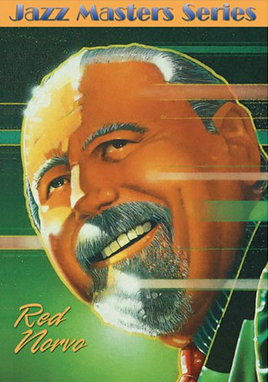

RED NORVO
“Club Anthony” – see RAY ANTHONY
"Jazz Masters Series: Red Norvo," Shanachie 6321, 2005 •
“Ocean’s 11 [ 1960 ],” Warner Home Video, Feb 2007
“Screaming Mimi [ 1958 ],” Sony Pictures Home Entertainment, Mar 2011
“Talmage Farlow: a film by Lorenzo DeStefano [ 1981 ],” MVD Visual, Apr 2006

WILL OSBORNE
“Blues in the Night [ 1941 ]” – see JIMMIE LUNCEFORD
"Swing Parade of 1946," GoodTimes Video 05-81124, 2000 • also with Jordan

TONY PASTOR
"Big Bands Vol 1, The: The Soundies" – see VARIOUS ARTISTS
"Big Bands Vol 2, The: The Snader Telescriptions" – see VARIOUS ARTISTS

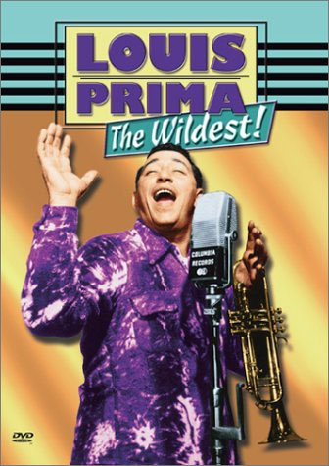
LOUIS PRIMA
"Jungle Book, The [ 1967 ],” Walt Disney Home Video, 1999 also with Harris
“Louis Prima: In Person!: His Wildest Performances 1936-1973,” S’more
Entertainment SMO-DV-7104, 2010 •
"Louis Prima: The Wildest!," Image Entertainment IDO535BUDVD, 1999 •
"Louis Prima and Keely Smith: That Old Magic," Passport Video, 2005
“Manhattan Merry-Go-Round” – see CAB CALLOWAY
“Rose of Washington Square [ 1939 ],” 20th Century-Fox Marquee Musicals, Oct 2008
"'You and Me:' featuring rare and previously unreleased stage performances and
Interviews with Louis Prima and the beautiful Keely Smith," 93028, 2000
“You Can’t Have Everything [ 1937 ],” 20th Century Fox Cinema Archives, Dec 2013 •

DON REDMAN
"Don Redman and His Orchestra" Melody Master film short included in 6-DVD set "The
Busby Berkeley Collection," Warner Brothers 67846, 2006

ALVINO REY
"Big Bands Vol 1, The: The Soundies" – see VARIOUS ARTISTS
"Christmas with the King Family," Polly O Entertainment / Infinity IEG2175, 2009 •
[ as seen on PBS; includes comments by Yvonne King and Marilyn King of The
King Sisters ]
“Classic TV Christmas Shows” – see VARIOUS ARTISTS

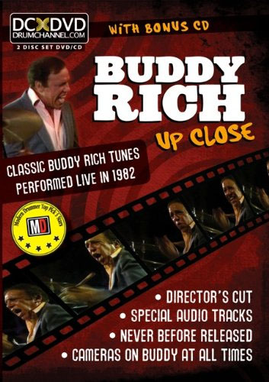

BUDDY RICH
“Big Bands At Disneyland [ 1984 ]” DVD-R TRANSFER •
“Buddy Rich and His Band: Channel One Suite [ 1985 ],” Hudson Music, Jun 2003
also available as part of the set “The Buddy Rich Collector’s Edition,” Hudson Music
“Buddy Rich and His Band: The Lost Tapes,” Lightyear, Oct 2005
“Buddy Rich and His Band: The Lost West Side Story Tapes,” Hudson Music
HD-Z-WS01, 2001 • also available as part of the set “The Buddy Rich
Collector’s Edition,” Hudson Music
"Buddy Rich at the top," Hudson Music, Aug 2002
"Buddy Rich Big Band Live 1986 & 1973," Impro-Jazz IJ532
"Buddy Rich: Jazz Legend 1917-1987," Warner Brothers Publishing 903792,
2002 •
"Buddy Rich Live At the 1982 Montreal Jazz Festival," Hudson Music, Feb 2004
"Buddy Rich: Live in '78," Jazz Icons DVWW-JIBRF, 2006 •
"Classic Drum Solos and Drum Battles Vol 1" – see VARIOUS ARTISTS
"Classic Drum Solos and Drum Battles Vol 2" – see VARIOUS ARTISTS
"Classic Jazz Drummers: Swing and Beyond" – see VARIOUS ARTISTS
“Frank Sinatra: Concert for the Americas”
“Tonight Show Starring Johnny Carson, The: Show Date 03/27/86,” Respond2
Entertainment, Nov 2010

FREDDIE RICH
"Freddie Rich and His Orchestra" 1938 film short included as "special feature" with
2-disc Errol Flynn "The Adventures of Robin Hood," Warner Home Video, Sep 2003

JAN SAVITT
"Jan Savitt and His Band" Warner Bros. film short included as "special feature" with film
"My Reputation" (available separately or as part of set "Barbara Stanwyck Signature
Collection"), Warner Home Video, Oct 2007

RAYMOND SCOTT
“Happy Landing [ 1938 ],” 20th Century Fox Cinema Archives, Dec 2013

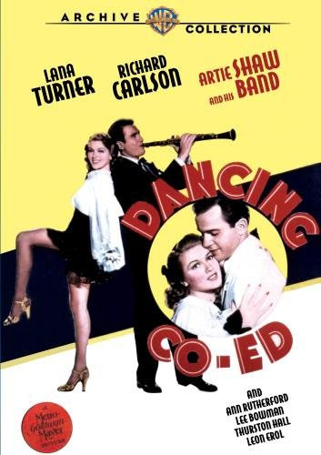

ARTIE SHAW
“Across 110th Street [ 1972 ],” MGM Soul Cinema 1002579 • cameo by Shaw and
wife Evelyn Keyes
“Artie Shaw at IAJRC [ 1998 ],” DVD-R TRANSFER •
“Artie Shaw: Time is all you’ve got,” DVD-R TRANSFER ••
“Big Bands At Disneyland [ 1984 ]” DVD-R TRANSFER •
"Bix: 'Ain't None of Them Play Like Him Yet” – see VARIOUS ARTISTS
“The Crash of Flight 401 [ 1984 ],” Charles Fries Productions DVD-R TRANSFER •
Shaw has a small dramatic role
“Dancing Co-ed [ 1939 ],” DVD-R TRANSFER •
"Dancing Co-ed [ 1939 ]," Warner Brothers Archive Collection, Jul 2010 •
"Jazz: A Film By Ken Burns" – see VARIOUS ARTISTS
“Jumpin’ and Jivin’: Vol 1” – see VARIOUS ARTISTS
"Second Chorus" [ 1940 ], Critics' Choice Video CCD 1070, 2004 • also incl
1939 short "Symphony of Swing"
"Second Chorus [ 1940 ]," Image Entertainment HRS 9455DVD [ HRS = Hal Roach
Studios series ]

THE ARTIE SHAW ORCHESTRA DIRECTED BY DICK JOHNSON
"Artie Shaw: The Band Keeps Swinging," Planet Song ( G ) 8604, 2004 • NOTE:
this disc is PAL format
“Big Band Ballroom Bash [ 1992 ],” DVD-R TRANSFER •
see also ARTIE SHAW

NOBLE SISSLE
"Harlem Double Feature: Junction 88 / The Black King," Alpha Video ALP5168D,
2006 • [ Sissle in "Junction 88" ]
“Murder with Music [ 1941 ],” Synergy Archive Series, Jul 2008

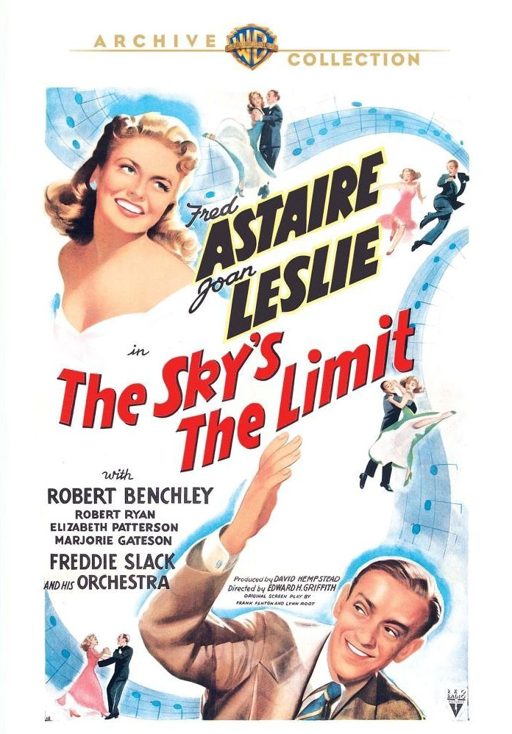

FREDDIE SLACK
"Sky's The Limit, The [ 1943 ]," Warner Bros. Archive Collection, 2012 •
“Startime: The Swingin’ Singin’ Years [ 1960 ]” – see VARIOUS ARTISTS

CHARLIE SPIVAK
"Pin-Up Girl [ 1944 ]," 20th Century Fox Marquee Musicals, 2005 •

JACK TEAGARDEN
"Big Band: One CD/One DVD" – see VARIOUS ARTISTS
“Dixieland Jazz Vol 1: The Snader Telescriptions” – see VARIOUS ARTISTS
“Jazz Legends: Louis Armstrong & His Friends” - see LOUIS ARMSTRONG

RUDY VALLEE
“Admiral Was a Lady, The [ 1950 ],” Alpha Video, Mar 2006
“Bachelor and the Bobby-Soxer, The [ 1948 ],” Turner Home Entertainment, Jun 2004
“Father Was a Fullback [ 1949 ],” 20th Century-Fox Cinema Archives, Nov 2012
“Glorifying the American Girl [ 1929 ],” Alpha Home Entertainment, Feb 2007
"Gold Diggers in Paris [ 1938 ]," Warner Home Video, Sep 2008 •
“How to Succeed in Business Without Really Trying [ 1967 ],” MGM, Apr 2000
“It’s in the Bag [ 1945 ],” Olive Films, Jan 2013
“Johnny Carson and Friends” – see VARIOUS ARTISTS
“Live a Little, Love a Little [ 1968 ],” Warner Home Video, Aug 2007
“Mother is a Freshman [ 1949 ],” 20th Century-Fox Cinema Archives, Oct 2012
“My Dear Secretary [ 1949 ],” Image Entertainment, Jun 2004
“Palm Beach Story, The [ 1942 ],” Universal Studios, Feb 2005
“People Are Funny [ 1946 ],” Alpha Home Entertainment, Jan 2008
“Sin of Harold Diddleback, The [ 1947 ],” Alpha Video, Jan 2004
“Slashed Dreams [ 1975 ],” Synergy Archive series, Jul 2008
“Time Out for Rhythm [ 1941 ],” – see GLEN GRAY
“Unfaithfully Yours [ 1948 ],” 20th Century-Fox Cinema Archives, Mar 2013
“Vagabond Lover, The [ 1929 ],” The Roan Group, Mar 2005

FATS WALLER
“Fats Waller: This Joint Is Jumpin’,” Screen Edge, Mar 2009
"Harlem Renaissance: Music & Rhythms That Started . . . “ – see VARIOUS ARTISTS
“Harlem Roots Vol 2: The Headliners” – see VARIOUS ARTISTS
“Jumpin’ and Jivin’: Vol 1” – see VARIOUS ARTISTS
“Legends of Modern Music Vol 2” – see VARIOUS ARTISTS
“Stormy Weather [ 1943 ]” - see CAB CALLOWAY

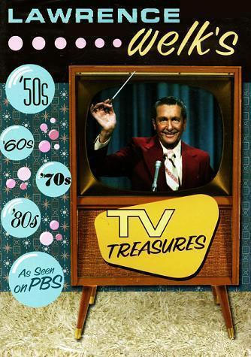

LAWRENCE WELK
“Classic TV Christmas Shows” – see VARIOUS ARTISTS
"From Lawrence Welk to America with Love [ 1997 ]," Welk Music Group, Oct 2003
“Holidays with Lawrence Welk, The,” Synergy Archive Series, Nov 2011 [ 3 DVDs ]
“Lawrence Welk 1958 / 1959/ 1966 Christmas Shows,” Synergy Archive Ser, Oct 2007
“Lawrence Welk: Classic Episodes Vols 1-4,” Synergy Entertainment, Feb 2012
“Lawrence Welk: Three Classic Episodes Vol 2,” Synergy Archive Series, Feb 2009
“Lawrence Welk: Three Classic Episodes Vol 3,” Synergy Archive Series, Oct 2008
“Lawrence Welk: Three Classic Episodes Vol 4,” Synergy Archive Series, Apr 2009
“Lawrence Welk: Three Classic Episodes Vol 5,” Synergy Archive Series, Aug 2009
"Lawrence Welk Family Christmas, A [ 1995 ]" – see TRIBUTES
"Lawrence Welk: God Bless America [ 2003 ]" – see TRIBUTES
“Lawrence Welk: Milestones & Memories . . . [ 2001 ]” – see TRIBUTES
"Lawrence Welk: Precious Memories [ 2005 ]" – see TRIBUTES
“Lawrence Welk Show: New Year’s Specials,” Synergy Archive Series, Dec 2008
“Lawrence Welk’s Big Band Splash [ 2011 ],” Welk Music Group 1439-9, Feb 2011 •
“Lawrence Welk’s Top Tunes & New Talent Show,” Synergy Archive Series, Nov 2009
“Lawrence Welk’s TV Treasures [ 2007 ],” Welk Music Group, Mar 2007
“Shower of Stars” – see VARIOUS ARTISTS
“Welk Stars Through the Years, The [ 2009 ]” – see TRIBUTES

PAUL WHITEMAN
“Atlantic City [ 1944 ]” also with Armstrong
"Bix: 'Ain't None of Them Play Like Him Yet” – see VARIOUS ARTISTS
“Fabulous Dorseys, The [ 1947 ]” – see THE DORSEY BROTHERS
“Rhapsody in Blue [ 1945 ],” Warner Bros. Archive Collection, Feb 2012
"Strike Up the Band" film included in "Mickey Rooney & Judy Garland Collection,
Warner Home Video, Sep 2007

TEDDY WILSON
“Benny Goodman: Let’s Dance [ 1985 ]” – see BENNY GOODMAN

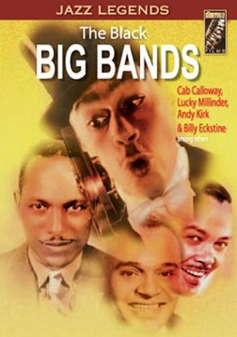

VARIOUS ARTISTS
"20th Century Jazz Masters: C Basie Plus E Hines . . . & L Armstrong," Idem 1149
"Alan Freed in Rock, Rock, Rock!," Alpha Video ALP5238D, 2006 [ disc includes
bonus" feature "Rhythm & Blues Review" incl Basie, Calloway, Hampton ]
“All-Star Christmas Show, The,” Wham! USA, 2008 Armstrong, Goodman
"All Star Swing Festival," Delta 82328 incl Basie, Goodman, Ellington, Wilson
“All You Need Is Love,” Tony Palmer TPDVDBOX1, 2008 • Shaw
"At the Jazz Band Ball: Early Hot Jazz, Song and Dance," Yahoo 514, 2000
Armstrong, Bernie, Dorsey Bros, Ellington, Whiteman
“Bert Stern’s Jazz On a Summer’s Day [ 1958 Newport, RI Jazz Festival ],” New Yorker,
- Armstrong, Teagarden
“Best of the Abbott and Costello Show, The: Vol 2,” Good Times, 2006 Armstrong
“Best of the Big Bands Vol 2,” TFCN Broadcasting, 2008 Kenton, Ellington, Cugat,
Beneke, Nelson, Barnet, Calloway, I Hutton, Fio Rito, Thornhill, Bradley, Clinton,
Hampton
“Best of The Johnny Cash TV Show, The: 1969-1971,” Sony Legacy, 2007
Armstrong
“Big Band Cavalcade, The” DVD-R TRANSFER • Carle, Crosby, Martin
"Big Band: One CD/One DVD," Request Records 38043, 2006 Basie, Ellington, James
"Big Band: One CD/One DVD," Request Records 38044, 2006 Calloway, Raeburn
“Big Band: One CD/One DVD,” Request Records, 2007 Beneke, Wald, Krupa, Kenton
“Big Bands Vol 1: Snader . . . ," Storyville Films 16004, 2003 • Ellington, Hampton
"Big Bands Vol 2: Snader . . . ," Storyville Films 16005, 2004 • Barnet, Brown, Pastor
"Big Bands Vol 1: Soundies," Storyville Films 16011, 2004 • Kenton, Pastor, Rey
“Big Bands Vol 2: Soundies,” Storyville Films 16012, 2004 • J Dorsey, Krupa, Bradley
“Billie Holiday: The Ultimate Collection,” Verve, 2005 Armstrong
"Bix: 'Ain't None of Them Play Like Him Yet,'" Playboy Jazz PBV 9043 • Shaw
"Black Big Bands, The," Storyville Films 16051, 2003 • Calloway, Millinder, Kirk
“Bob Hope: Hollywood’s Brightest Star,” Simitar Ent., 1999 Arnaz
"Cabin in the Sky" [ 1943 ], Warner Home Video 67678, 2006 • Armstrong, Ellington
"Classic Drum Solos and Drum Battles Vol 1," Hudson Music, 1988 Rich, Bellson
"Classic Drum Solos and Drum Battles Volume 2," Hudson Music
incl. Rich, Hampton, Krupa
"Classic Jazz Drummers: Swing and Beyond," Hudson Music
incl. Armstrong, Teagarden, Krupa, Rich, Calloway, Hampton
"Classic Musical Shorts From the Dream Factory," Warner Archive Collection, May 2010
• incl. a half-dozen of Martin Block's "Musical Merry-Go-Round" shorts from 1948,
with Martin, Beneke, Brown, Noble, Carle; NOTE: not all material is by big bands
“Classic TV Christmas Shows,” Synergy Archive Series, Nov 2012 Welk, Rey
“Disneyland USA,” Walt Disney Treasures Armstrong [ 2 DVDs ]
“Dixieland Jazz Vol 1: The Snader Telescriptions,” Storyville Teagarden, Bobcats
“Entertaining the Troops: Amer Entertainers In World War II,” Mississippi Pub Bdctng
“Film Classics: Big Bands: Basie / Ellington / James” DVD-R TRANSFER •
“Film Classics: Big Bands: Basie / Hampton / Ellington” DVD-R TRANSFER •
“Film Classics: Big Bands: Beneke / Krupa / Wald / Kenton” DVD-R TRANSFER •
“Film Classics: Big Bands: Clinton / J Dorsey / Nichols / Berigan . . . ” DVD-R T’FER •
“Film Classics: Big Bands: Ellington / Basie / Hampton” DVD-R TRANSFER •
“Film Classics: Big Bands: James / McKinley / Zentner / Marterie” DVD-R T’FER •
“Film Classics: Big Bands: Kemp / Long / Carle / Garber / Mooney” DVD-R T’FER •
“Film Classics: Big Bands: McKinley / Stabile / Donahue / Kenton” DVD-R T’FER •
“Film Classics: Big Bands: Welk / Morgan / Kemp / Garber” DVD-R TRANSFER •
“Genius of Charlie Christian, The,” View Video 2353, 2005 • Goodman
“G.I. Jive” DVD-R TRANSFER • Calloway, Eldridge
“Golden Age of Musicals, The,” St Clair Entertainment, 2008 [ 3 DVDS ] Dorsey Bros
"Great Day in Harlem, A: The Story and Sounds Behind the Most Famous Photo in the
History of Jazz!," Image Entertainment 3035, 2006 Gillespie
“Harlem Jazz Festival,” Video Dimensions Basie, Hampton, Ellington, Calloway
"Harlem Renaissance: The Music & Rhythms That Started a Cultural Revolution," Kultur
incl. Calloway, Ellington, Basie
"Harlem Roots Vol 1: Big Bands," Storyville Films 16000, 2004 • Basie, Millinder
“Harlem Roots Vol 2: The Headliners,” Storyville Films, 2007 Jordan, Waller
"Hollywood Rhythm: The Paramount Musical Shorts Vol 1,” Kino Video, 2001 Calloway
"Hollywood Rhythm Vol 2: Best of the . . . ,” Kino Video K198, 2001 Vallee, Shaw
“Inspirational treasures From The Ed Sullivan Show” Armstrong
“Jam Session [ 1944 ]” Barnet, Armstrong, Rey, Garber, G Gray, Powell
"Jazz: A Film By Ken Burns," PBS DVD GoldB8262, 2000 • Shaw
“Jazz Festival Vol 2,” Storyville Films Ellington, Hackett, Auld DE facing right
"Jazz Festival Vol 2," Storyville 16074, 2003 • Ellington, Hackett, Auld DE facing left
“Jazz Icons: Series 1,” Jazz Icons, 2006 [ 9 DVDs ] Gillespie, Basie, Rich, Armstrong
“Jazz Legends in Concert [ 1993 ],” Kultur Video, 2010 Basie Orch, Hampton, Jacquet
“Jazz On a Summer’s Day [ 1958 Newport, RI Jazz Festival ],” Indie Europe / Zoom,
2009 Armstrong, Teagarden
"Jazz Shots: East Coast, Vol 2," Eforfilms 9053, 2005 incl Armstrong, Basie, Hackett
"Jazz Shots: East Coast, Vol 3," Eforfilms 9054, 2005 incl Ellington, Herman
“Johnny Carson and Friends,” PC Treasures, Inc Vallee
“Juke Box Saturday Night” DVD-R TRANSFER • Crosby
“Jumpin’ and Jivin’: Vol 1,” Acorn Media, 2007 Calloway, Waller, Shaw, Jordan
“Legendary Crooners, The,” Standing Room Only, 2007 Armstrong
“Legends of Modern Music Vol 2,” PNH/Edu2000, Sept 2012 Armstrong, Waller
"Make Mine Music" [ 1946 ], Walt Disney Home Video, 2000 Goodman
"Mario Lanza," Bel Canto Society #D129 James and Betty Grable from Sep 30, 1954
“Masters of American Music: the story of jazz,” BMG Spec Prod Armstrong
“Monterey Jazz Festival: 40 Legendary Years,” Warner Home Video, 1999
Armstrong, Basie
“More Jazz and Big Band Classics: 27 Fabulous Recordings,” 2007 Basie, Gillespie,
Calloway, Armstrong
“My Music: The Big Band Years: A Sentimental Journey” • Beneke, Brown, Shaw
“New York,” PBS DVD Gold, 1999 Armstrong
“Paris Blues,” Ripley’s Home Video, 2010 Armstrong, Ellington
“Play Your Own Thing: A Story of Jazz in Europe,” Euro Arts / Medici Arts, 2008
Armstrong, Ellington, Gillespie
"Ralph Gleason's J Casual: Inst Vol 1," Rhino Home Video R2 976664, 2000 •
“Ralph Gleason’s Jazz Casual: Louis Armstrong / Earl ‘Fatha’ Hines,” Idem, 2008
“Rock ‘n Roll Revue / Rhythm and Blues Revue,” Mill Creek Entertainment, 2005 •
“Roots of Rhythm [ PBS, 1997 ],” New Video Group, 2001 Cugat, Gillespie, Arnaz
“Saved from the Flames: 54 Rare and Restored Films 1896-1944,” Flicker Alley, 2008
Ellington, Armstrong
“Sentimental Journeys [ 1984 ]” DVD-R TRANSFER • McKinley
“Shower of Stars,” Synergy Archive Series, Aug 2012 Welk
"Sid Caesar Collection: The Magic of Live TV," Goldhil Home Media, 2000 [ "Sid Plays
Sax with Benny Goodman" ]
“Silver Screen Series: Hi-De-Ho / Beware / Reet, Petite…,” Echo Bridge 2004 Jordan
“Sinatra: The Classic Duets,” Sinatra Enterprises, 2010 Armstrong
"Small Black Groups, The," Storyville Films 16052, 2003 • Kirby, Jordan
"The Sound of Jazz: Complete Edition," Idem 1158 incl Basie
"Song Is Born, A," MGM, Apr 2009 • Goodman, T Dorsey, Armstrong, Barnet
“Stage Door Canteen [ 1943 ],” Hal Roach Studios Basie, Kyser, Lombardo, Martin
“Startime: The Swingin’ Singin’ Years [ 1960 ]” DVD-R TRANSFER • Herman, Martin
“Startime: The Swingin’ Singin’ Years [ 1960 ],” Synergy Entertainment, 2011
"Swing Era: Dinah Washington" (i.e., "Female Swing Era Vocalists, Vol 1"), Idem 1120
incl. Dinah Washington, Sister Rosetta Tharpe, June Richmond
"Swing Era: Peggy Lee" (i.e., "Female Swing Era Vocalists, Vol 2"), Idem 1121
incl. Peggy Lee, June Christy, Ina Ray Hutton
"Swing Era: Sarah Vaughan" (i.e., "Female Swing Era Vocalists, Vol 3"), Idem 1122
incl. Sarah Vaughan, Lena Horne, Ethel Waters
"Swing Era: Duke Ellington [and] Lionel Hampton," Idem 1123
"Swing Era: Stan Kenton" (i.e., "Bands, Vol 1"), Idem 1125 incl Barnet, Brown, Thornhill
"Swing Era: Count Basie" (i.e., "Bands, Vol 2"), Idem 1126 incl Waller, Armstrong,
Krupa, Millinder
"Swing Era: George Shearing" (i.e., "Bands, Vol 3"), Idem 1127 incl The Bob Cats,
Flanagan, Pastor
"Swing Era: Benny Goodman" (i.e., "Bands, Vol 4"), Idem 1128 incl Goodman, Shaw,
J Dorsey, Teagarden
"Swing Era: Big Band Legends," Idem 1153 incl Shaw, T Dorsey, J Dorsey, G Gray,
Clinton, Hutton, Cugat
"Swing Era: Rhythm in a Riff," Idem 1154 incl Eckstine, Kirk, Kirby, Beneke, Long,
Nelson, Messner
"Swing Era: Boogie Woogie & Rhythm 'n' Blues," Idem 1155 incl Bradley
"Swing Era: Dixielanders," Idem 1156 incl Nichols
"This Joint Is Jumpin’," Image Ent ID9694CDDVD, 2000 • Shaw, Hampton, Anthony
“This Joint Is Jumpin’,” MPI DVD7830, Aug 2007 Shaw, Hampton, Anthony
“USO Christmas Show,” EastWest DVD Armstrong
“Variety At the Apollo Theatre,” Storyville Films, 2005 Hampton, Calloway
“Very Best of The Ed Sullivan Show: Vol 1,” Sofa Entertainment, 2005 Armstrong
"Warner Brothers Big Band, Jazz & Swing Short Subject Collection," Warner Archive
Collection. Nov 2009 Shaw, Herman, J Dorsey, others • [ 6 DVDs ]

TRIBUTES
“2008 Buddy Rich Memorial Concert,” Drum Channel, Aug 2009
“Buddy Rich Memorial Scholarship Concerts: The Complete Los Angeles & New York
Concerts,” Alfred Music, Jul 2006
“Dixieland Jazz Vol 1: The Snader Telescriptions” – see VARIOUS ARTISTS
"Eddy Duchin Story, The [ 1956 ]," Columbia Pictures 07867, 2002 •
“Glenn Miller 60th Anniversary 2nd Wycombe Abbey Concert [ 1994 ],”
DVD-R TRANSFER •
“Glenn Miller Birthplace Society Big Band [ 2010 ],” DVD-R TRANSFER •
“Glenn Miller Museum [ 2010 ],” DVD-R TRANSFER •
"Glenn Miller Story, The [ 1954 ],” Universal 22635, 2003 •
"Lawrence Welk Family Christmas, A [ 1995 ]," Welk Music Group, Oct 2003
"Lawrence Welk: God Bless America [ 2003 ]," Welk Music Group, Feb 2003
“Lawrence Welk: Milestones & Memories: A Musical Family Reunion [ 2001 ],”
Welk Music Group, Jul 2004
"Lawrence Welk: Precious Memories [ 2005 ]," Welk Music Group, Jan 2005
“Making of Burning for Buddy, The: A Tribute to the Music of Buddy Rich,” Alfred
Music, Dec 2006
“Mike Vax Big Band, The: Featuring alumni of the Stan Kenton Orchestra: Live!
At the 1995 Morningside College Jazz Festival: Vol 1”
“Miller Magic: Glenn Miller Wycombe Abbey Concert [ 1988 ],” DVD-R
TRANSFER •
“Salute to Buddy Rich, A: featuring Phil Collins, Dennis Chambers, & Steve Smith
[ 2004 ],” Hudson Music, May 2004
“Welk Stars Through the Years, The [ 2009,” Welk Music Group
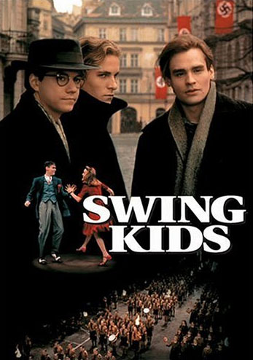

PERIOD
"All-American Co-Ed" / "Swing Hostess," Alpha Video [ the latter title, made in 1944,
stars former Benny Goodman vocalist Martha Tilton ], Oct 2008
“Swing Kids,” Hollywood Pictures 26913 •

sources
Amazon.Com
Popa Family Collection
Scott Yanow. Jazz On Film (San Francisco, CA: Backbeat Books, 2004)

